Ironing Cover for a 30” x 72” Banquet table
Materials
Insulbright: Cut 1 (30” x 72”)
Cotton or Cotton batting with 20% polyester: Cut 1 (30” x 72”)
Ironing board fabric: Cut 1 (39” x 81”) I prefer the silver surfaced fabric. It doesn’t stain. I use a lighter weight if it is going to be a portable cover. The heavier fabric is much nicer on a permanent board.
Felt Marker
Heavy elastic (3/4” x 40”)
Heavy cording: (5 times the length of your table). This is going to draw the underside of the ironing cloth tighter. Clothes line is too stiff. String snaps.
ABS plumbing pipe: 1 (4’ x 1 ½”) cut into 4 equal lengths
ABS plumbing caps: 4 caps to be the feet of the extenders (this eliminates scratching floors and snagging carpets) Glue is not necessary, just snap them on.

Directions The padding; I do the padding separate because it has outlasted a couple of my covers.
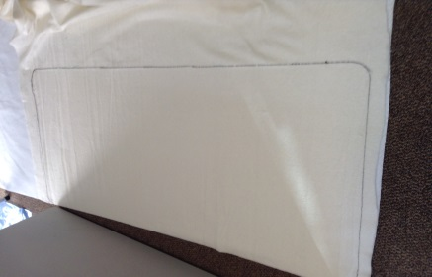
1 Lay the insulbright on the floor shiny side down. 2 Place the batting on top. 3 If you can, put your ironing table or board upside down on the batting, leaving about ¼ “ of batting showing on one long side. (If you cannot, lay the batting on top of the table) 4 Use the felt marker to mark around the table, aprox. ¼” from the edge of the table edge. (Pressing the side of the marker against the table as you draw works well.) 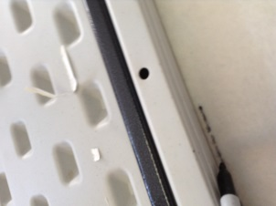
5 Rough cut outside the line, then pin outside and inside the line. 6 Surge or zig zag on the line. Trim close to the line.
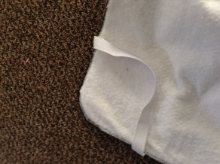
7 Cut the elastic into 4 equal lengths. 8 Place the padding on the table. Slide the elastic under the table at 45° until the elastic is slightly stretched. Pin and sew the elastic to the padding.

The cover;
1 Place the cover wrong side up on the floor. 2 If you can, put your table or board upside down on the cover leaving 4 ½” showing on one long side. 3 Use the felt marker and a ruler to mark approx. 4 ½”around the remaining 3 sides. 4 Cut on the line.
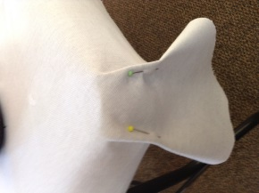
5 Sit the table right side up. Lay the cover wrong side down on the table with 4 ½” extending past the table edges. Pin 2 folds at each corner on either side of the curve. Stitch the folds, cut on the fold line to within ½” from the top of the table and pin open.
6 Trim the points. 7 Surge or zig zag the outer edge.
8. Fold the edge of the cover to the inside far enough for the cord to slide through easily. Stitch the edge down, start and stop at the middle of the sides leaving a gap on each side.
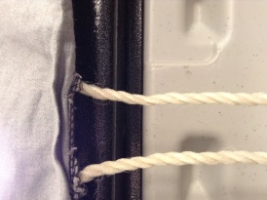
.
9. Thread a length of cord from each side to the other leaving enough cord to tie a bow where the 2 cords will meet.
You will have cord left over. It is used to pull the sides together.

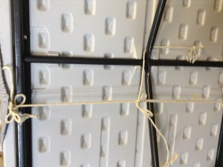
10 When the padding and cover are on your ironing table, pulled tight on both sides and tied; thread the left-over cord between the bows and the cover on each side. Pull the cord ends to the middle of the underside of the table and tie off tight enough to prevent the cover shifting when you are ironing.
By Lynne Weisgerber 2016

