Instructions for the Cardiac Pillow Construction

Included in your package: (there are usually two set of everything listed below)

- Heart pillow fronts (printed with the arteries of the heart) groups of 5 pinned together.

- Heart pillow backs (printed with “Donated by Royal Columbian Hospital Auxiliary”) groups of 5 pinned together.

- 1 lb. of fibrefill - enough for stuffing 5 pillows.

With the right sides together, sew a front and back approx... 3/8 – ½ inch seam allowance all around the heart leaving an opening of about 5-6 inches to allow you to turn the pillow and put your hand inside for stuffing once turned. Start sewing along a straight part of the heart. Stitch from the edge, then turn and sew around the pillow, leaving the opening, turn and sew to the edge. This makes it easier to sew the pillow closed once stuffed. See diagram below:
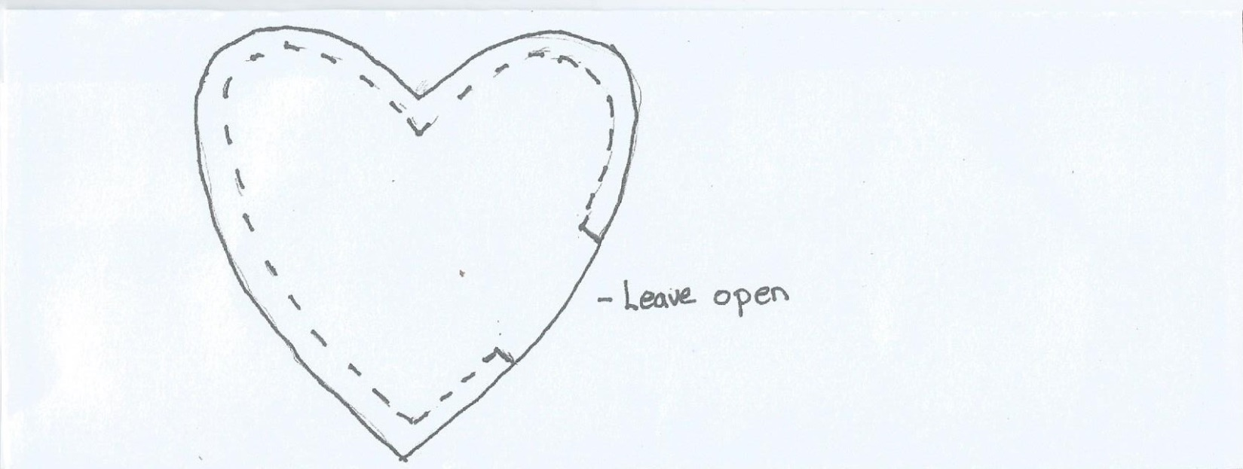

Clip the curves in a few places and at the heart notch, careful not to clip your stitched line.

Stuff the pillow, then machine stitch the opening closed. Each pound of fibrefill is enough for 5 pillows (or approx. 3.3 oz.)

Place the completed pillows in the bag your supplies came in and return to Laurie Parrent at the guild meeting, or contact her at lparrent@shaw.ca or phone: 604-463-2458 or cell 604-838-5533.

Thank you for supporting the Cardiac Surgical Program and Hospital Auxiliary at Royal Columbian Hospital. The pillows are given to the open heart surgery patients as a reminder and support aid for post- surgical sternal precautions.

